2022 9th International Power Electronics Systems and Applications (PESA)

Title

Wireless Motors – A New Breed of Power Electronics Drives

Abstract

To wire, or not to wire, that is the question: Whether electric motors should go wireless. The pros and cons of wireless motors will be introduced, hence identifying the conflict and tradeoff between system cost, transmission efficiency, electrical safety and working environment. Differing from the pseudo-wireless version which is actually a cascaded combination of the wireless power transfer system and the motor, the wireless motors should not involve any batteries, controllers or active devices at the motor side, while performing speed control at the transmitter side. Three key types of wireless motor technology will be presented, namely the wireless DC motors, wireless AC motors and wireless switched reluctance (SR) motors. Their potential applications will also be discussed, with emphasis on those desiring high flexibility, electrocution-free and applicable in totally sealed or isolated environment. Finally, research opportunities and technological challenges of this new breed of power electronics drives will be revealed.

Brief Bio
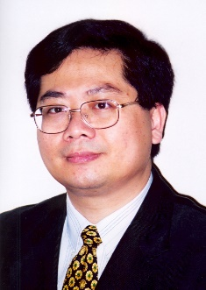

K. T. Chau received his B.Sc.(Eng.) degree with First Class Honours, M.Phil. degree, and Ph.D. degree all in Electrical & Electronic Engineering from The University of Hong Kong. He joined the alma mater in 1995, and subsequently served as Director of the International Research Centre for Electric Vehicles, Associate Dean of Engineering and Head of Department of Electrical & Electronic Engineering. Currently, he serves as Professor in the Department. He is a Chartered Engineer, Fellow of the IET, and Fellow of the HKIE. He is elected Fellow of the IEEE for Contributions to Energy Systems for Electric and Hybrid Vehicles. He has been honoured the IEEE Vehicular Technology Society Distinguished Lecturer and Distinguished Speaker. Now, he is serving as Editor of the Studies in Science and Technology, Co-Editor of the Journal of Asian Electric Vehicles, Section Editor-in-Chief of the Energies, and Editorial Board Member of some international journals. His main areas of research are Electric Vehicle Technologies, Electric Drives and Power Electronics, where he has published 9 books, 9 book chapters and over 300 refereed journal papers.

